**The Willow Tree Children’s Centre**

**Illness Prevention and Infectious Disease Control Policy**

**Statement of Intent**

At the Willow Tree Children’s Centre, it is our aim to minimise the spread of infection for staff, Catkins, pre-school, and school-age children through the implementation of controls which reduce the transmission and spread of germs. We aim to promote and maintain the health of children and staff through the control of infectious illnesses.

**Aims**

* We aim to control infection by providing on- going infection control training for staff (handwashing, respiratory hygiene, food hygiene, sanitation, cleaning).
* Exclusion guidelines as recommended by the Health Service Executive apply in the case of all suspected infectious conditions (See exclusion notes for the different diseases outlined in Chapter 9 of [Management of Infectious Disease in Childcare Facilities and Other Childcare Settings](http://www.hpsc.ie/a-z/lifestages/childcare/File,13444,en.pdf) (2012) page 33.) This policy is available to all parents and staff on the website [www.blennerville.playschool.com](http://www.blennerville.playschool.com)
* This policy will also be reviewed with staff at induction and annual staff training.
* A copy of all policies will be available during all hours of operation to staff members and parents/guardians upon request.
* Parents/guardians may receive a copy of the policy at any time upon request.
* Parents/guardians and the staff team will receive written notification of any updates.
* A notification will be posted on the door to the classroom should staff, children, or visitors to the centre report the presence of any contagious condition to the centre.

This policy is compliant with Regulation 23 - Safeguarding Health, Safety and Welfare of child of the Child Care Act 1991 (Early Years Services) Regulations 2016 and the Child Care Act 1991 (Early Years Services) (Registration of Pre-school and school-age Services) Regulations 2018. The Willow Tree Children’s Centre shall ensure that all reasonable measures are taken to safeguard the health, safety and welfare of a child attending the service and that the environment of the service is safe. The following measures are taken to safeguard the health, safety and welfare of a child attending the service:

**Procedures**

If a child is displaying symptoms of being unwell at the Willow Tree Children’s Centre, the parent(s) will be advised to collect their child immediately and contact their general practitioner. During this time the child displaying symptoms will wait in an area away from the other children (a chair near the bag area in the acorns room and a sectioned off area near the bag area of the catkins room). If for some reason, the parent cannot collect they should organise an authorised adult to collect their child.

The child presenting with symptoms will sit down on a chair with a member of staff who may wear a mask, apron and gloves. Whether gloves are worn or not, it is essential that both the child and the staff member should avoid touching their face, nose, mouth or eyes and to perform hand hygiene in accordance with the HSE guidelines. The windows in both rooms remain open at all times for ventilation. In line with our Infectious Disease Exclusion policy the child will not return to the setting until they are feeling better and their temperature returns to normal.

The same procedure applies for a staff member presenting with symptoms. If a staff member has a high temperature or any other symptoms of illness, they should not enter the service. If symptoms present during the workday, that staff member should gather their belongings and go home immediately.

**Reporting/Recording of illness:**

* + A contingency plan is in place should an outbreak of an infectious disease occur. All staff roles and responsibilities regarding reporting procedures are clearly defined.
  + Staff will report any infectious illness to the Pre-school Owner / Manager.
  + The Manager will report an outbreak of any infectious disease to the HSE Preschool Environmental Health Officer and the Public Health Department.
  + Although staff will no longer check temperature at the door, the option is available to any staff, child, or visitor to the setting who requests it.
  + Staff will check the body temperature of any staff, child, or visitor to the setting who display symptoms of illness.
  + Staff will record all details of illness displayed within the service.
  + There will be an assigned isolation area whereby, children can isolate following a suspected outbreak of an infectious disease until collection is possible.

**Immunisations**

We encourage you to get your child immunised according to the HSE recommendations. Although, we also respect parent’s right to choose immunisation for their child and understand that not all children will be immunised who attend the service. Children in groups are prone to picking up infections and it can spread quickly. It is our belief immunisation gives a child protection from disease as well as protecting others around them especially those too young from immunisation. The service is legally obliged to keep a record of all children’s immunisations and asks parents to note all immunisations before the child starts: • Name, date of birth; • Age at which immunisation is due and date given; • Date vaccination record was sighted; • Where/ by whom it was given; • Whether the child is up to date with immunisations; • If the child has not been immunised, the reasons why, e.g. parental choice/ underlying medical condition. The service will keep a record of children who have not received immunisation. Should there be an infectious outbreak all parents and staff will be notified in writing and, where necessary, verbally. It is the responsibility of the family to keep the service up to date with the child’s immunisations. All staff members should be fully immunised.

**Precautionary Approach:**

In line with the most up to date guidance, we are taking a precautionary approach to uphold the safety of our children, families and staff. This means that if a staff member, child or someone in their household or family unit is displaying ANY symptoms of Covid19 or any other infectious disease; they should not attend the service. Any symptoms of concern should be discussed with their GP. Further information is available on the first 5 website <https://first5.gov.ie/guidance>. This low threshold approach is so important to ensure the safe continued opening of our service.

**Exclusion from the Service:**

* + Children will be excluded from the service based on the timeframes outlined by the Health Service Executive (See exclusion notes for the different diseases outlined in Chapter 9 of [Management of Infectious Disease in Childcare Facilities and Other Childcare Settings](http://www.hpsc.ie/a-z/lifestages/childcare/File,13444,en.pdf) (2012) page 33.)
  + Children with the following cannot be admitted to the service:

• Acute symptoms of food poisoning/gastro-enteritis.

• Is symptomatic and displaying a temperature of over 37.5 degrees C.

• Displaying a temperature of 38 degrees C or over, regardless of symptoms.

• An earache.

•A deep, dry or hacking cough.

• Sore throat/symptoms of respiratory infection.

•Severe congestion.

•Difficulty breathing or untreated wheezing.

• An unexplained rash.

• Vomiting (in last 48hours).

•Diarrhoea (in last 48 hours).

•Complaints of a stiff neck and headache with one or more of the above symptoms

•Untreated Lice or nits

• An infectious /contagious condition.

•A child who is on an antibiotic for less than 48 hours

* + A doctor’s certificate may be required for certain conditions to ensure they are no longer contagious before children return to the service.
  + Parents are required to complete a Return to Childcare Declaration Form on the day of their child returning to our service.
  + Children and adults should not attend if they have symptoms of a viral infection.
  + If your child has symptoms of viral respiratory disease, even if they are mild, they must not attend a childcare setting.
  + Likewise parents who have respiratory symptoms must not take their child to a setting or pick them up.
  + Parents must not take their child to the childcare setting if a parent or anyone at home is suspected of having or known to have Covid- 19, or other infectious illness/disease. If this is unavoidable a mask should be worn while in the setting.
  + If a child is displaying symptoms of a virus the parent(s) will be advised to collect their child immediately and contact their general practitioner. If, for some reason, the parent cannot collect they should organise an authorised adult to collect their child.
  + In line with our fees policy, Fees must be paid even when the child is absent due to illness, except in special circumstances and with the agreement of the management committee /manager. If a child will not be attending, we require one week’s notice or you will be charged in full. Last minute cancellations will be charged in full.

**Hand washing Procedure for Staff:**

This poster is displayed at all handwashing sinks and reminders to sanitise at all sanitising stations.

**Handwashing Procedure for Children:**

We implement the handwashing with Rufus programme. These step-by-step guides are located at all child level sinks. Staff support children in developing this skill through supervision, modelling and song.

This poster is displayed at all child hand washing sinks and at child level to reinforce the hand washing procedure in a fun and child friendly way.

Children should remain at home if they are suffering from general diarrhoea or vomiting until 48 hours after being symptom free.

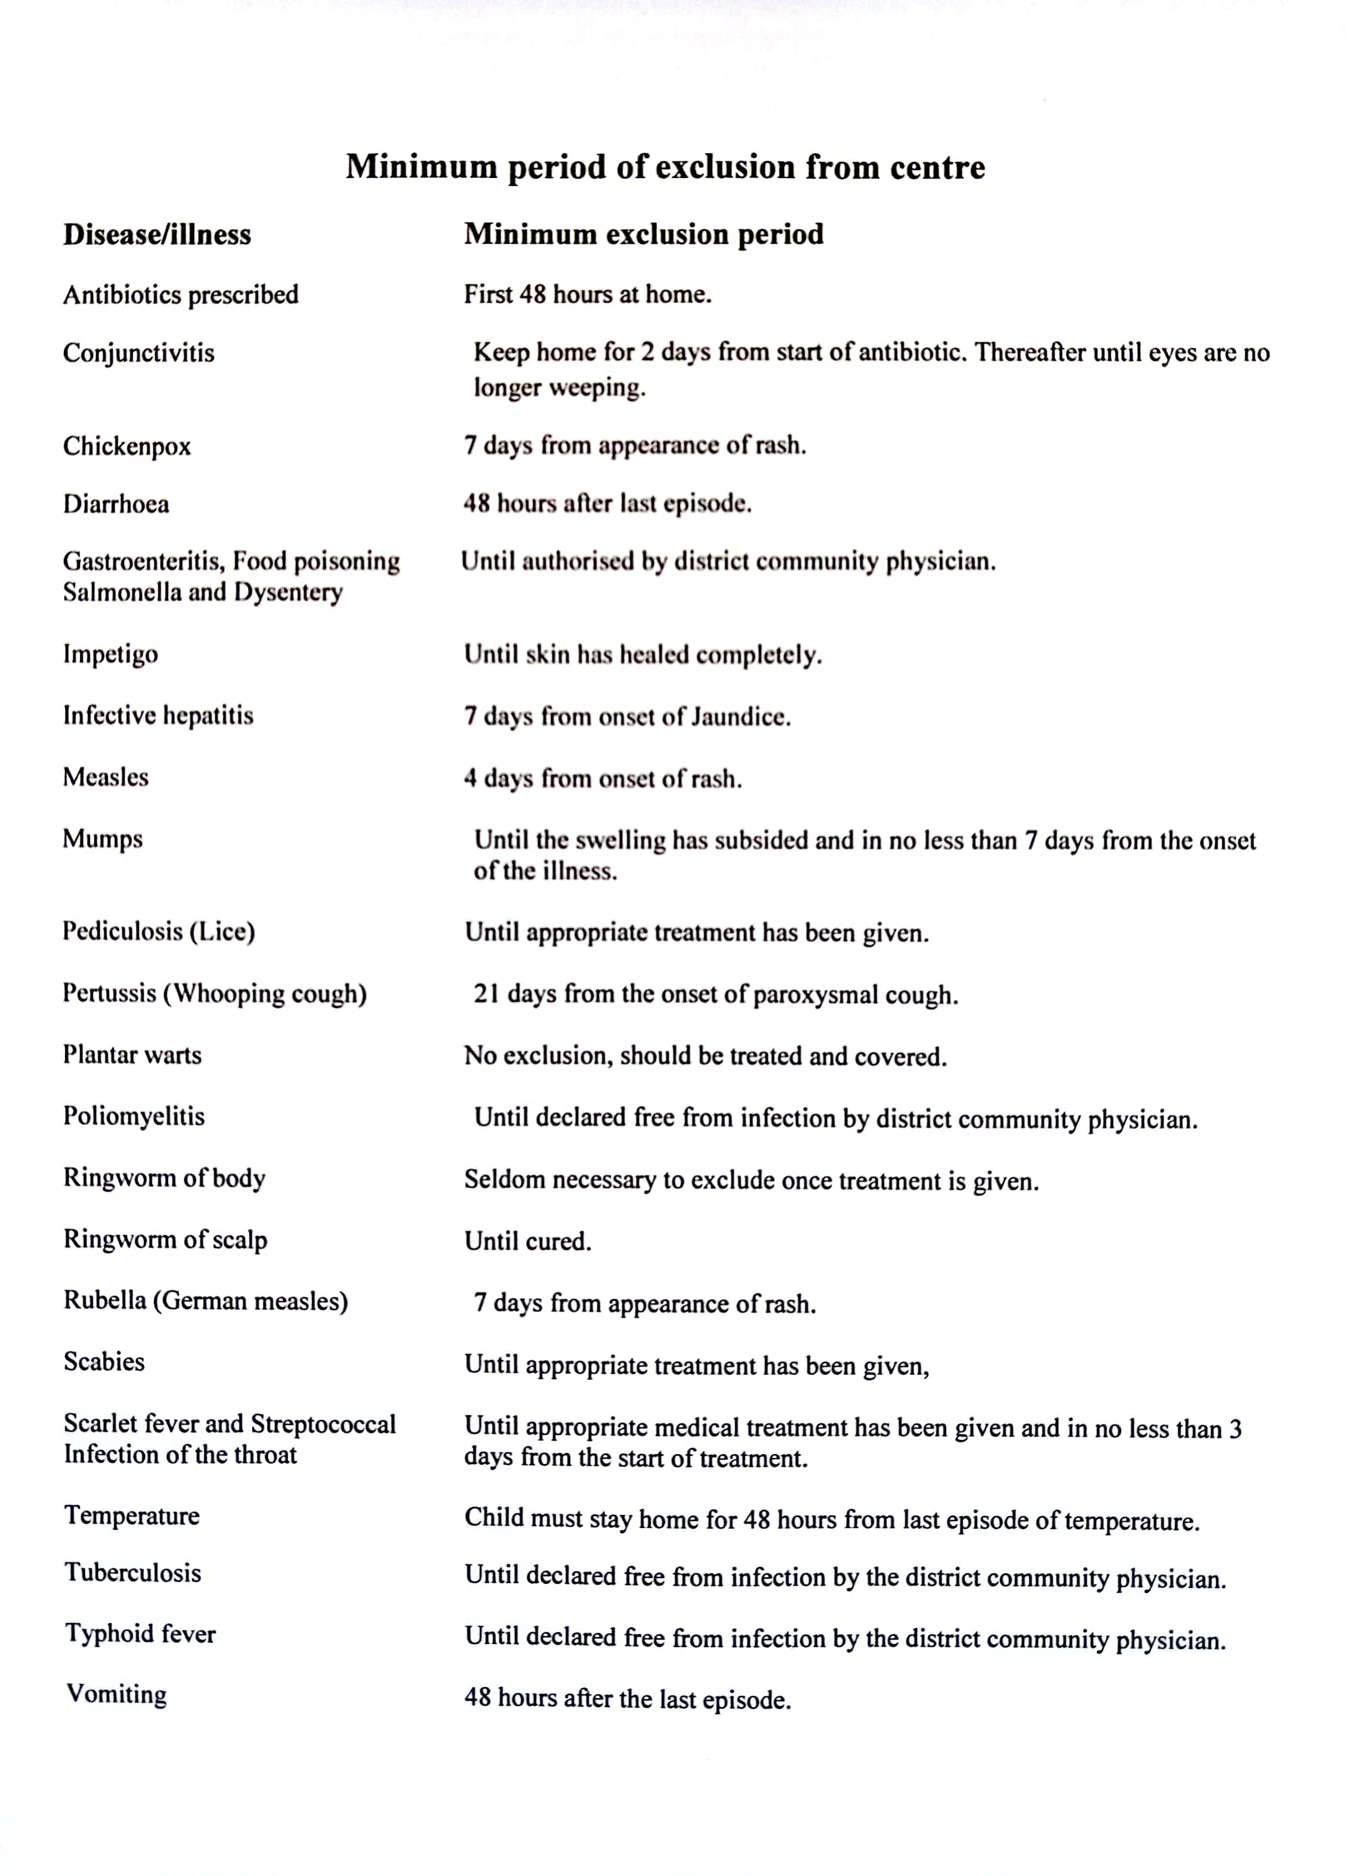

**Hand Hygiene/ Respiratory Hygiene:**

* + Hand washing facilities are always available for children and include hot (not exceeding 43 degrees)and cold water, liquid soap and paper hand towels.
  + Hand washing facilities are available in all toilets, kitchens, and in the classroom.
  + Sanitiser dispensers containing an alcohol based sanitiser (60%) will be available for staff and visitors upon entrance of the building, entrances and exits of each room).
  + Children are encouraged and reminded to wash their hands after using the toilet, before eating and after playing outside and there are hand washing posters displayed at children’s level near the wash hand basins. We follow the Washing Hands with Rufus the Messy Monster Programme (safefood.eu)
  + Children are encouraged to engage in good respiratory hygiene when coughing or sneezing e.g. cough/sneeze into their elbow or catch their cough. This will be demonstrated in a fun and interactive way during circle time or during other engaging learning activities.
  + Staff must wash their hands:
* before preparing or serving food
* before feeding children
* before eating or drinking
* after going to the toilet
* after assisting children at the toilet
* after nappy changing
* after dealing with any body fluids
* after cleaning procedures
* after caring for sick children
* after handling soiled clothing or items
* after dealing with waste
* after removing disposable gloves and/or aprons.
* Staff are trained in Hand washing technique as advised by HSE guidelines: Wet hands under hot water (not exceeding 430C for children to prevent scalding), apply liquid soap, rub vigorously paying particular attention to palms, backs, wrists, fingernails and fingers and rubbing between each finger and around the thumbs, rinse, dry thoroughly using disposable paper towels and turn off taps using the paper towel.

**Toilets and potties:**

* Toilet areas, including toilet handles, doors, toilet seats and wash hand basins are cleaned twice daily in accordance with the cleaning schedule and immediately if soiled.
* Potties are emptied into the toilet, cleaned (with hot water and detergent) and disinfected after each use.
* Trainer seats are thoroughly cleaned (with hot water and detergent) and disinfected after each use.

**Nappy Changing**

* Nappy changing is only carried out in the designated nappy changing area.
* Parents will provide creams or lotions for their child, these will not be shared.
* The changing mat and area will be cleaned (with hot water and detergent) and disinfected and dried thoroughly after use.
* Disposable gloves are worn by staff when changing a nappy.
* Soiled nappies are placed in an impervious bag which is tied and disposed of in a lidded bin and emptied each day.
* The nappy changing area is cleaned in accordance with the cleaning schedule.
* Changing mats are regularly checked to ensure the cover is not cracked or torn. Changing mats will be discarded of in such an event.

**Bodily Fluid Spillage**

* Spills of blood, vomit, urine or excreta will be cleaned up as quickly as possible. The area will be sectioned off if possible until the spill has been dealt with.
* Disposable plastic gloves are worn when cleaning up any bodily fluid spillage. Paper towels are used to clean up spillages and placed directly into a plastic bag for disposal.
* Advanced Cleaning Sanitiser freshly diluted (1 to 10 parts water), is used for cleaning and disinfection of bodily fluid spillages. (This solution should not make contact with skin. If accidental contact does occur, the skin, eyes or mouth should be flushed with cold water.
* Disposable paper towels and gloves, are disposed of in a plastic bag and sealed.
* A supply of sanitiser and plastic bags are kept together in a secure place in each room in case of such an incident.

**Food and Kitchen Hygiene**

* Staff involved in toileting children or nappy changing are not involved in food handling.
* Staff will not engage in any aspects of minding children while preparing food.
* Kitchen Cleaning Schedules and Checklists are on Display in the kitchen and Cleaning is recorded after each clean.

**Cleaning**

* All areas are cleaned regularly in accordance with a documented cleaning policy and rota. Toilets, sinks and hard contact surfaces (playroom tables) are cleaned twice daily.
* Toys and materials are to be sanitised after each group to prevent cross contamination.
* Each room will be cleaned thoroughly prior to the next group of children entering.
* Hot spots or frequently touched areas (door handles, window handles etc)
* All cleaning equipment is kept separate to each area and easily distinguished e.g. colour coded which is displayed clearly in classroom and kitchen.
* Playroom tables are cleaned before being used for meal and snack times.
* Extensive cleaning rotas for the various rooms are available to staff and can be found in the office, and both rooms.

**Toys and Equipment**

* Toys and equipment will be cleaned according to the toy cleaning programme and schedule.
* Toys and equipment will be cleaned with hot water and detergent and disinfectant.
* We request that children do not bring any toys from home unless it is a comfort toy and needed by the child for sleep. Any comfort toy should be washed and cleaned.
* Mouthed toys which have been used will be kept in a labelled box and washed daily and will be monitored for breakages/splits and disposed of when this occurs.
* Children's soother containers are sanitised daily with the steam gun, they are then washed in the dishwasher and placed in the tower steamer each Friday. Sippy cups and soothers are washed daily.

**Laundry**

* Each child is provided with their own linen, which is individually labelled and kept in labelled containers. Linen used for cots and sleep mats are washed weekly unless soiled.
* Linen is washed in the hottest washing cycle degree of the washing machine.
* Cleaning cloths used in the playrooms, kitchen and sanitary accommodation are washed separately daily.

**Outings to farms or zoos**

* Children will wash and dry their hands after contact with animals, animals cages as well as before eating and when leaving the farm/zoo.
* All meal breaks will be taken in designated areas away from where the animal’s kept.
* Children will be constantly supervised during their visit to the farm or zoo. The importance of hand washing will be reiterated to the children by staff throughout the visit.

## Communication Plan [For staff & families]

All parents/guardians are to be informed of the policy and procedures regarding Illness Prevention and Infectious Disease Control on enrolment. Staff members will check with parents/guardians that they have read and understood the policy and provide any assistance needed.

A summary of this policy will be included in the Parent/Guardian Handbookand the full policy is available on the website www.blennerville.playschool.com

This policy will also be reviewed with staff at induction and annual staff training. When a complaint is received, the person making the complaint will be given a copy of this Policy and Procedures.

A copy of all policies will be available during all hours of operation to staff members and parents/guardians upon request.

Parents/guardians may receive a copy of the policy at any time upon request.

Parents/guardians and the staff team will receive written notification of any updates.

This policy was reviewed and adopted by The Willow Tree Children’s Centre on 13th August 2024.

Signed by: ___________________________

On behalf of Management

**Address:**

The Willow Tree Children’s Centre,

Ground Floor Unit,

96 Carraigbeag,

Clogher Faili,

Tralee,

Co. Kerry

V92Y510

**Contact Telephone Number:** 066-7122765 Or 085 2808034

**Email address:** blennerville.playschool@gmail.com

**Website:** www.blennervilleplayschool.com

**Registered Proprietor:** Jessica Hastings

**Person in Charge:** Laura MacKenna

**Deputy Person in Charge**: Danielle Berry